What is a Kubernetes ingress? How is it used?
A Kubernetes ingress is an API object that allows external traffic to be routed to the appropriate Kubernetes services based on the incoming request’s URL or host. It is used to expose HTTP and HTTPS routes to the Kubernetes cluster.
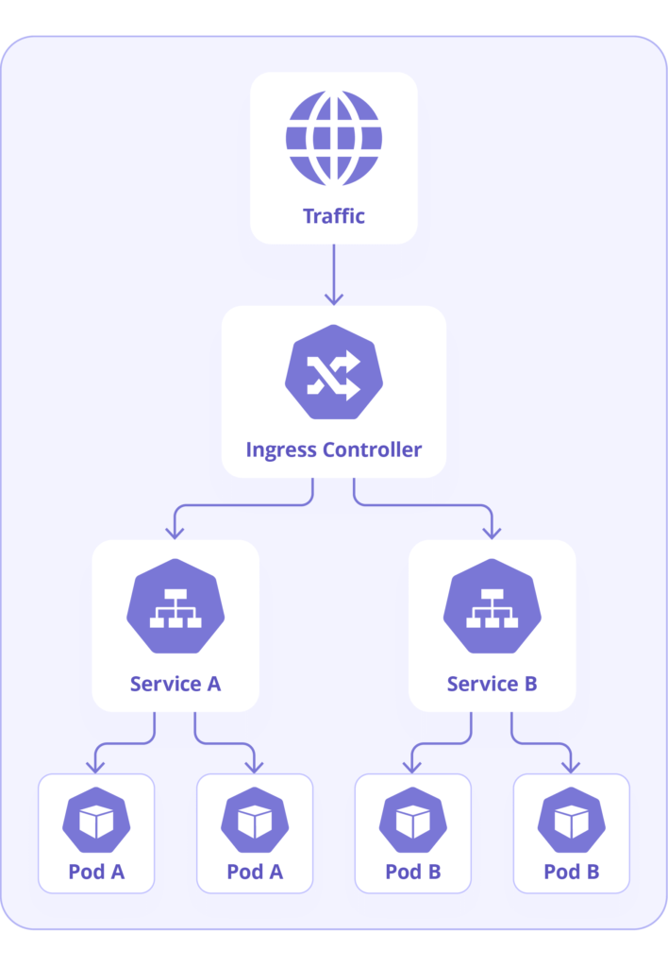
How do you handle secrets and configuration management in Kubernetes?
Kubernetes provides a built-in secret’s API resource for securely storing sensitive information such as passwords, API keys, and other confidential data. Kubernetes also allows for configuration management using config maps, which can be used to store non-sensitive configuration data as key-value pairs.
How do you automate Kubernetes deployments?
Kubernetes deployments can be automated using various tools such as Helm, Kubernetes Operators, or GitOps workflows. Helm is a package manager for Kubernetes that allows users to define, install, and upgrade Kubernetes applications. While Kubernetes Operators are a Kubernetes-native way of automating application management, GitOps relies on Git as the source of truth for defining and deploying Kubernetes applications.
How do you scale Kubernetes applications horizontally and vertically?
Scaling Kubernetes applications can be done horizontally or vertically. Horizontal scaling involves adding more replicas of the application, while vertical scaling increases the resources of the individual pod. Kubernetes supports both types of scaling, and it can be easily achieved by modifying the replica count or resource limits of a deployment or Statefulset.
What is the difference between a Kubernetes namespace and a label?
A Kubernetes namespace is a way to divide cluster resources between multiple users or teams. It provides a way to isolate resources and prevent naming conflicts. On the other hand, Kubernetes labels are key-value pairs attached to Kubernetes objects to help identify and organize them.
How does Kubernetes handle load balancing and network traffic routing?
Kubernetes uses a Service object to handle load balancing and network traffic routing. A Service provides a single IP address and DNS name for a set of pods and routes traffic to those pods based on a set of rules defined by the user.

How do you deploy a stateful application in Kubernetes?
Deploying a stateful application in Kubernetes requires using Statefulsets, which provides guarantees around the ordering and uniqueness of pod startup and termination.
What is the difference between a Kubernetes deployment and a Kubernetes Daemonset?
A Kubernetes deployment manages a set of identical replicas of a defined application instance. It ensures that the desired number of replicas are running and monitors their health. Deployments manage the creation, update, and scaling of pods, which are the basic units in Kubernetes.
On the other hand, a Kubernetes Daemonset ensures that all the nodes in a cluster run a copy of a specific pod. A Daemonset controller creates pods on each node in the cluster and then monitors them to ensure they are healthy. Daemonsets are helpful for deploying cluster-level applications such as log collectors and monitoring agents.

What is the difference between Kubernetes deployment and Kubernetes StatefulSets?
A Kubernetes deployment is suitable for stateless applications, while a Statefulset is ideal for stateful applications like databases. A deployment is designed to handle simple scaling and zero downtime rolling updates. In contrast, a Statefulset offers more guarantees on the ordering and uniqueness of pods and persistent storage.

What is a Kubernetes network policy? How does it work?
A Kubernetes network policy is a specification that defines how groups of pods can communicate with each other and with the outside world. It is used to enforce network traffic rules that restrict access to pods based on their labels or namespaces. Network policies use selectors and rules to allow or deny incoming or outgoing traffic between pods.
What is the difference between a Kubernetes Daemonset and a Kubernetes Statefulset?
Both Kubernetes Daemonsets and Statefulsets are used to manage pods, but they have different use cases. Daemonsets are used for running pods on every node in a cluster, while Statefulsets are used for deploying stable, ordered pods with unique network identities.
What is a storage class in Kubernetes? How is it used?
A storage class is a Kubernetes object that defines the type of storage that can be used by a pod or a persistent volume claim (PVC). Storage classes are used to dynamically provision storage resources based on the requirements of the application.
What is a Kubernetes deployment rollout strategy? Name a few different types of strategies.
A Kubernetes deployment rollout strategy is used to update a deployed application to a new version. Some common deployment strategies include RollingUpdate, Recreate, and Blue/Green

How does Kubernetes handle security and access control? What are some best practices for securing a Kubernetes cluster?
Kubernetes provides several built-in security features, such as role-based access control (RBAC), pod security policies, and network policies. Best practices for securing a Kubernetes cluster include applying security updates regularly, using strong authentication and access controls, and using network segmentation to separate resources.
What is a Kubernetes Operator, and how is it used?
A Kubernetes Operator is a method for packaging, deploying, and managing Kubernetes-native applications. An Operator defines a set of custom resources and controllers to automate the management of complex applications.
What is the role of a Kubernetes Service Mesh, and why would you use one?
A Service Mesh is a dedicated infrastructure layer designed to manage service-to-service communication within a Kubernetes cluster. Service Meshes provide authentication, authorization, and observability features for distributed systems.
What is a Kubernetes ConfigMap? How is it different from a Kubernetes Secret?
A Kubernetes ConfigMap is an object used to store configuration data that a pod or container can consume. On the other hand, a Kubernetes Secret is used to store sensitive information, such as a password or API key.
Can you explain the process of a rolling update in Kubernetes?
Rolling updates in Kubernetes replace old pods with new ones incrementally, maintaining service availability. Managed through deployments, this process ensures that a certain number of pods are always operational, allowing for a smooth transition between versions and enabling quick rollbacks if issues arise, thus minimizing downtime.
What are liveness and readiness probes in Kubernetes, and how are they used?
Liveness probes in Kubernetes check if an application inside a pod is running, restarting it if the check fails. Readiness probes determine if the application is ready to process requests, ensuring Kubernetes directs traffic only to pods ready for it. These probes help maintain application reliability and availability.
How does Kubernetes’ scheduler decide where to place pods?
The scheduler in Kubernetes assigns pods to nodes based on resource requirements, node policies, and scheduling constraints like affinity and anti-affinity. It evaluates the resource needs of each pod and finds a suitable node with sufficient capacity, optimizing resource utilization and fulfilling specific deployment requirements.

How does Kubernetes handle persistent storage and dynamic provisioning?
Kubernetes handles persistent storage via Persistent Volumes (PVs) and Persistent Volume Claims (PVCs), supporting various storage backends. Dynamic provisioning automates PV creation in response to PVC requests, ensuring consistent and reliable storage allocation without manual intervention, facilitating stateful application management.

What is the role of RBAC (Role-Based Access Control) in Kubernetes?
Role-Based Access Control (RBAC) in Kubernetes manages user and process permissions, defining who can access which resources and operations. It uses roles to define permissions and bindings to assign those roles to users or groups, enhancing security by ensuring only authorized access to cluster resources.
management, aiding in troubleshooting and operational insights.
How does Kubernetes’ Horizontal Pod Autoscaler (HPA) work, and when would you use it?
The Horizontal Pod Autoscaler (HPA) automatically adjusts the number of pod replicas in a deployment based on observed CPU utilization or other specified metrics. Used to maintain performance during varying load, HPA scales out (increases replicas) during high demand and scales in (reduces replicas) during low usage, optimizing resource use.
How does Kubernetes’ service discovery mechanism work?
Service discovery in Kubernetes automatically assigns a stable DNS name and IP address to each service, allowing other pods to discover and communicate with services reliably. This mechanism simplifies internal communication within the cluster, ensuring that services can easily locate and connect with each other regardless of node placement.
How can you ensure zero-downtime deployments in Kubernetes?
Zero-downtime deployments are achievable in Kubernetes using strategies like rolling updates, which gradually replace old pods with new ones, ensuring service availability. Properly configured readiness and liveness probes help manage the application state during deployment, avoiding downtime. Blue/green deployment and canary releases also contribute to maintaining availability by allowing testing of new versions alongside stable production versions before full rollout, minimizing the impact of potential errors.
How do Kubernetes init containers differ from regular containers?
Init containers in Kubernetes are specialized containers that run before the main application containers in a pod. They are used to perform setup tasks such as preparing configurations, ensuring prerequisites are met, or waiting for external services to become available, ensuring the main containers start with the correct setup or dependencies. Unlike regular containers, init containers must complete successfully before the main application containers start, providing a sequenced, step-by-step initialization process.
Horizontal scaling
Adding more pods (instances of your application) to distribute the load across multiple nodes
Vertical Scaling (VPA):
Increasing the resources (CPU, memory) allocated to existing pods within the same node.
How does Kubernetes help in containerized deployment?
Kubernetes helps in containerized deployment by scaling, loading, balancing, and monitoring containers.
What are clusters in Kubernetes?
In Kubernetes, a cluster is a group of one or more machines (nodes) that work together to run containerized applications.

Can you tell me about kube-proxy?
Kube-proxy is a network proxy and load balancer that runs on each node in a Kubernetes cluster. It's responsible for routing traffic between Services and Pods, ensuring that traffic can be directed to the appropriate Pods, even if they are behind a Service's virtual IP. kube-proxy typically uses iptables or IPVS to manage network rules, which are created based on Service and EndpointSlice objects.
kubelet in Kubernetes
In Kubernetes, the Kubelet is the primary node agent that runs on each node, responsible for managing containers and pods on that specific node.
It is used for communication between the Kubernetes control plane and the individual nodes, ensuring containers are launched and maintained correctly. The Kubelet interacts with the container runtime (like Docker or containerd) to manage container lifecycle and reports the node's status to the control plane.
Namespaces in Kubernetes
Namespaces are used to isolate resources within a Kubernetes cluster. Sometimes, services in a different namespace might have to access a service located in another namespace. In such scenarios, you can use the ExternalName service provided by Kubernetes. An ExternalName service is a special service that does not have selectors and instead uses DNS names.
kind: Service
apiVersion: v1
metadata:
name: my-service
spec:
type: ExternalName
externalName: my.database.example.com
When you want to do curl -v http://my-service or curl -v http://my-service.default.svc.cluster.local according your namespace(in this example it is default), it will redirect you at the DNS level to http://my.database.example.com.
What is Kubernetes ExternalName Service type?
In simple terms, when you want to expose your resources to other users, you use a service. An ExternalName is a type of service that maps a service to a DNS name. You can think of it as a normal service that provides connectivity to other resources, and you can also link it to other services.
Use cases of ExternalName service type
So, the very first use case is, let’s suppose you have an external database service like RDS, and there are multiple microservices using that database. Now, suppose there emerges a need to change the endpoint for your database. To do that, you need to change the endpoint in all the microservices one by one. You can understand it in the diagram below.
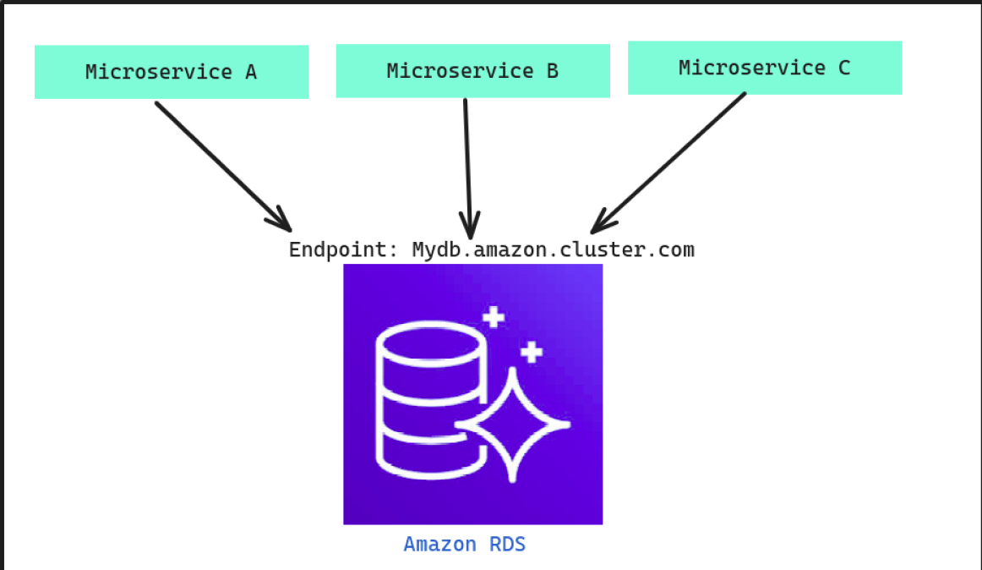

As shown in the diagram, we have three different microservices, but they are all connected to the same RDS with the same endpoint. Now, the problem arises when we need to change the endpoint from Mydb.amazon.cluster.com to Mydb1.amazon.cluster.com. This requires changing it in every microservice individually, which can be time-consuming. Now, let’s suppose we create an external service to connect with Amazon as shown below.
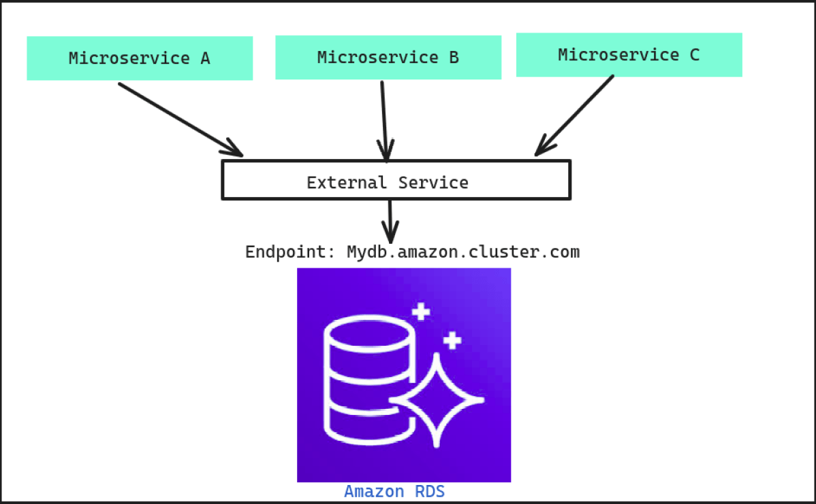
Now, as you can see, the external service is playing the role of a mediator. The microservices will connect with the external service, and the external service will then connect them to the actual endpoint. Now, even if the endpoints get changed, we only need to modify the endpoint inside the external service.
Importance of external service
- Time-saving
- Reduce code complexity
- Provide security

Where not to use ExternalName service type
Just to make sure that the ExternalName service type does not work with the IP address if you try to provide an IP instead of a DNS name then it will not work, So you should avoid it when you have a resource IP however you can configure a domain for that IP and then that domain to map with the service.

Demo:
1. Setup an ExternalName service type (service.yaml)
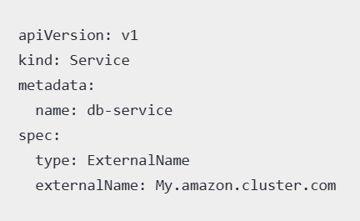
2. Passing ExternalName service name using an environment variable(deployment.yaml)
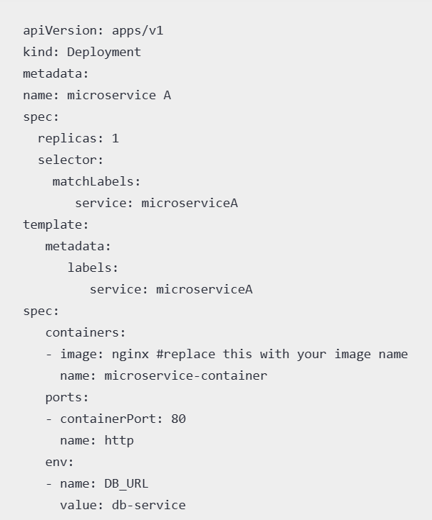
Now deploy both the manifests and then you can use the environment variable DB_URL inside your code to connect to database.
https://blog.nashtechglobal.com/kubernetes-externalname-service-type/

https://medium.com/@bubu.tripathy/headless-k8s-service-924c689607a7

https://kodekloud.com/blog/kubernetes-headless-service/

https://www.containerssimplified.com/learning/headless-service-in-k8s/
https://support.huaweicloud.com/intl/en-us/ae-ad-1-usermanual-cce/cce_faq_00289.html
https://www.bogotobogo.com/DevOps/Docker/Docker_Kubernetes_Headless_Service.php

Volume
A Kubernetes volume is a directory that contains data accessible to containers within a Pod
hostpath Volume:
Mount a directory /var/local/dataas a volume from the host machine to /usr/share/nginx/html location of the nginx container of a pod.
Any data written by the nginx-ontainer at /usr/share/nginx/html location will be persisted at /var/local/data location of the host machine. If the pod terminates, data will remain safe at /var/local/data location.
An NFS share volume allows a remote NFS file system to be mounted as a volume within a container or Kubernetes pod, enabling access to the shared files as if they were local. This is useful for persistent storage and data sharing across containers or machines.
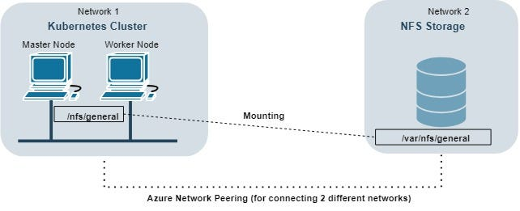
AWS EBS Volume
Create a volume using AWS-CLI and note down the “VolumeId” for attaching the volume to a pod.
https://www.groundcover.com/blog/kubernetes-pvc

https://devtron.ai/blog/kubernetes-labels-and-selectors-a-definitive-guide-with-hands-on/
https://www.civo.com/academy/kubernetes-concepts/labels-and-selectors

